**WEEK-8**

**NAME-SANCHIT JAIN**

**BATCH-B-7**

**ENROLL-21103192**

**1.** #include <iostream>

#include<string.h>

class Student;

using namespace std;

class Department

{

    char *name_p;

public:

    Department(char *dName)

    {

        cout << "Department::ctor\n";

        name_p = new char(sizeof(strlen(dName)));

        name_p = dName;

    }

    char *dName() const

    {

        return (name_p);

    }

    ~Department()

    {

        cout << "Department::dtor\n";

        delete (name_p);

    }

};

class Student

{

    char *name_p;

public:

    Student(char *sName)

    {

        cout << "Student::ctor\n";

        name_p = new char(sizeof(strlen(sName)));

        name_p = sName;

    }

    char *sName() const

    {

        return (name_p);

    }

    ~Student()

    {

        cout << "Student::dtor\n";

        delete (name_p);

    };

};

class Course

{

    Student *std_p;

    Department *dept_p;

    char *courseName_p;

    static unsigned int index;

    static Course *courseList[4];

public:

    Course(char *crseName, Student *student, Department *dept) : courseName_p(0), std_p(student), dept_p(dept)

    {

        cout << "Course:ctor\n";

        if (index < 4)

        {

            courseName_p = new char(sizeof(strlen(crseName)));

            courseName_p = crseName;

            courseList[index] = this;

            ++index;

        }

        else

        {

            cout << "Cannot accomodate any more Course\n";

        }

    };

    ~Course()

    {

        cout << "Course:dtor\n";

        delete (courseName_p);

    };

    static char *findStudent(char *crseName, char *deptName)

    {

        for (int i = 0; i < index; i++)

        {

            if ((courseList[i]->getCourseName() == crseName) &&

                (courseList[i]->getDeptName() == deptName))

            {

                return (courseList[i]->getStdName());

            }

        }

    }

    char *getStdName() const { return (std_p->sName()); };

    char *getDeptName() const { return (dept_p->dName()); };

    char *getCourseName() const { return (courseName_p); };

};

unsigned int Course::index = 0;

Course *Course::courseList[4] = {0, 0, 0, 0};

int main()

{

    int i;

    cout << "\nExample of Association class...\n";

    cout << "-----------------------------------\n\n";

    cout << "We have got 4 students ...\n";

    Student *studentNames[4] = {new Student("SANCHIT"), new Student("DHRUV"), new Student("Teena"), new Student("MRINAL")};

    cout << "\n";

    cout << "We have got 2 Departments...\n";

    Department *departNames[2] = {new Department("Mathemetics"), new Department("ComputerSceince")};

    cout << "\n";

    cout << "Here class Course Associates Student and Department, with a Course name ...\n";

    Course course1("DataStructure", studentNames[0], departNames[1]);

    Course course2("Maths", studentNames[3], departNames[0]);

    Course course3("Geometry", studentNames[2], departNames[0]);

    Course course4("CA", studentNames[1], departNames[1]);

    cout << "\n";

    cout << "Finding a Student using Course and Department...\n";

    cout << "Student who has taken Maths Course in Mathemetics Department is:" << Course::findStudent("Maths", "Mathemetics") << endl;

    cout << "\n";

    cout << "Deletion of objects...\n\n";

    for (i = 0; i < 4; ++i)

    {

        delete studentNames[i];

    }

    cout << "\n";

    for (i = 0; i < 2; ++i)

    {

        delete departNames[i];

    }

    cout << "\n";

    return (0);

}

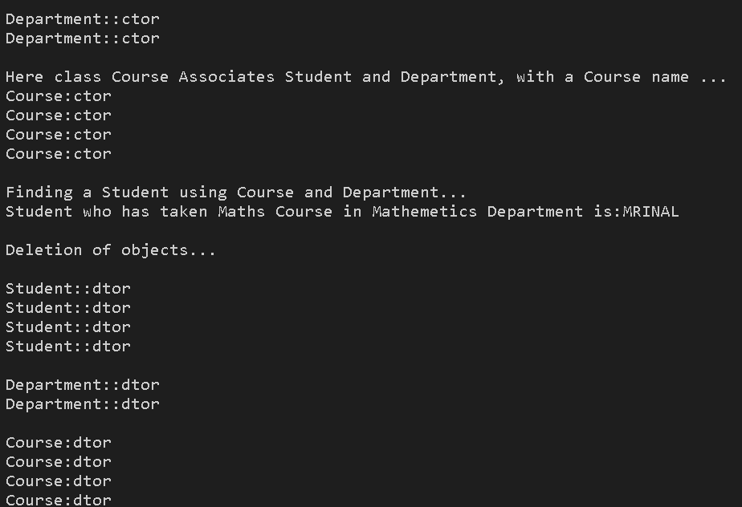

**2.** #include <iostream>

#include<string.h>

using namespace std;

class Employee

{

public:

    Employee(char *name)

    {

        cout << "Employee::ctor\n";

        myName_p = new char(sizeof(strlen(name)));

        myName_p = name;

    }

    char *disp() { return (myName_p); };

    ~Employee()

    {

        cout << "Employee:dtor\n\n";

        delete (myName_p);

    }

private:

    char *myName_p;

};

class Company

{

public:

    Company(char *compName, Employee *emp)

    {

        cout << "Company::ctor\n";

        name = new char(sizeof(strlen(compName)));

        name = compName;

        myEmp_p = emp;

    };

    ~Company()

    {

        cout << "Company:dtor\n\n";

        myEmp_p = NULL;

    };

private:

    char *name;

    Employee *myEmp_p;

};

int main()

{

    cout << "\nExample of Aggregation Relationship \n";

    cout << "-----------------------------------------\n\n";

    {

        cout << "Here, an Employee-PASHA works for Company-MS \n";

        Employee emp("PASHA");

        {

            Company comp("MS", &emp);

        }

        cout << "At this point Company gets deleted...\n";

        cout << "\nBut Employee-" << emp.disp();

        cout << " is still there\n";

    }

    return (0);

}

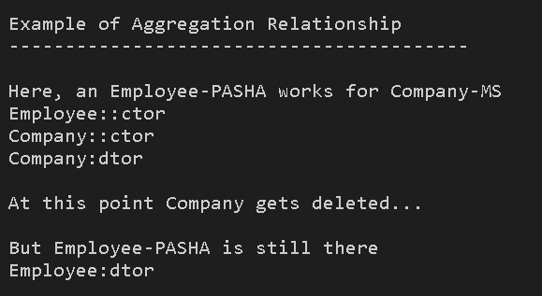

**3.** #include <iostream>

#include<string.h>

using namespace std;

class House;

class Room

{

public:

    Room(){};

    static void createRoom_v(Room *(&room), House *hse, char *name)

    {

        room = new Room(hse, name);

    }

    Room(House *hse, char *myName)

    {

        cout << "Room::ctor\n";

        myHse_p = hse;

        if (NULL != myHse_p)

        {

            name_p = new char(sizeof(strlen(myName)));

            name_p = myName;

        }

        else

        {

            cout << "Oops House itself is not Created Yet ...\n";

        }

    };

    ~Room()

    {

        cout << "Room:dtor\n";

        myHse_p = NULL;

        delete (name_p);

    };

    void disp()

    {

        cout << name_p;

        cout << "\n";

    }

    static void initList_v(Room *(&roomsList_p)[3])

    {

        roomsList_p[3] = new Room[3];

    }

private:

    House *myHse_p;

    char *name_p;

};

class House

{

public:

    House(char *myName)

    {

        cout << "House::ctor\n";

        name_p = new char(sizeof(strlen(myName)));

        name_p = myName;

        Room::initList_v(roomsList_p);

        Room *myRoom;

        Room::createRoom_v(myRoom, this, "Kitchen");

        roomsList_p[0] = myRoom;

        Room::createRoom_v(myRoom, this, "BedRoom");

        roomsList_p[1] = myRoom;

        Room::createRoom_v(myRoom, this, "Drwaing Room");

        roomsList_p[2] = myRoom;

    }

    ~House()

    {

        cout << "House:dtor\n";

        unsigned int i;

        cout << "Delete all the Rooms ...\n";

        for (i = 0; i < 3; ++i)

        {

            if (roomsList_p[i] != NULL)

            {

                delete (roomsList_p[i]);

            }

        }

        delete[] roomsList_p;

        delete (name_p);

    }

    void disp()

    {

        cout << "\n\nName of the House :" << name_p;

        if (roomsList_p != NULL)

        {

            unsigned int i;

            cout << "\n\nRooms details...\n";

            for (i = 0; i < 3; ++i)

            {

                if (NULL != roomsList_p[i])

                {

                    roomsList_p[i]->disp();

                }

            }

            cout << "\n\n";

        }

    }

private:

    char *name_p;

    Room *roomsList_p[3];

};

int main()

{

    cout << "\nExample of Composition Relationship\n";

    cout << "-----------------------------------------\n\n";

    House hse("Vishranti Nilaya");

    cout << "\n\nHouse details...\n";

    hse.disp();

    cout << "Here House itself creates the Rooms and Deletes as well, before it gets deletd...\n";

    return (0);

}

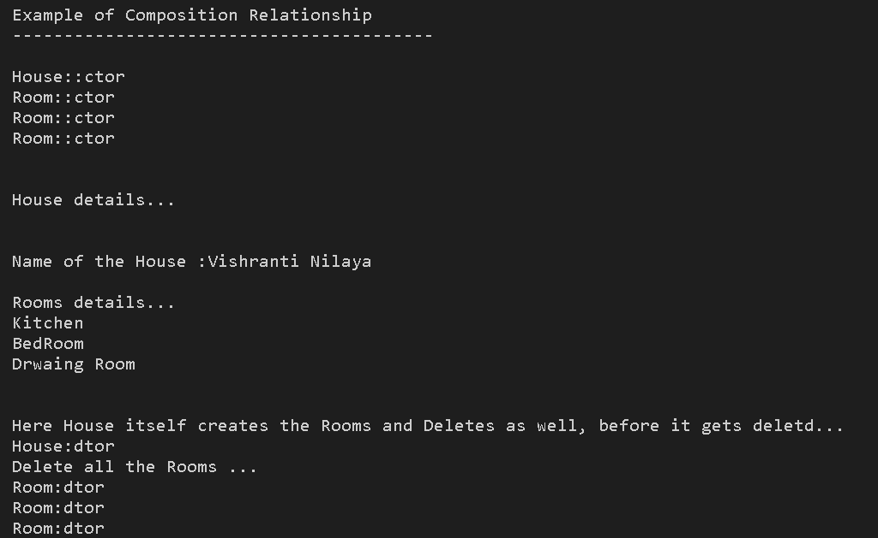

**4.** class Vehicle

{

    int wheelBase;

    int maxPower;

    int seat;

    public:

        void pressAccelerator();

        void turnWheel();

        void pressBreak();

};

**5.** #include <iostream>

using namespace std;

class Vehicle

{

    int wheelBase;

    int maxPower;

    int seat;

public:

    void pressAccelerator();

    void turnWheel();

    void pressBreak();

};

class wheel

{

};

int main()

{

    wheel w();

    {

        Vehicle v1();

    }

    return 0;

}

**6.** class Vehicle

{

    int wheelBase;

    int maxPower;

    int seat;

    public:

        void pressAccelerator();

        void turnWheel();

        void pressBreak();

};

class Car : public Vehicle

{S

};

class Lorry: public Vehicle

{

};

**7.** #include<iostream>

using namespace std;

class Vehicle

{

    int wheelBase;

    int maxPower;

    int seat;

public:

    void pressAccelerator();

    void turnWheel();

    void pressBreak();

};

class Person

{

};

int main()

{

}